# Exp 02:To Build Your Application using AWS CodeBuild and Deploy on S3 / SEBS using AWS CodePipeline, deploy Sample Application on EC2 instance using AWS CodeDeploy.

**Step 1: Create our ElasticBeanstalk Environment**

Login into your AWS account and navigate to services. Search for Elastic Beanstalk service and click on create application. Give your application a suitable name. For the platform, select PHP. Rest of the configuration settings are to be kept as default.

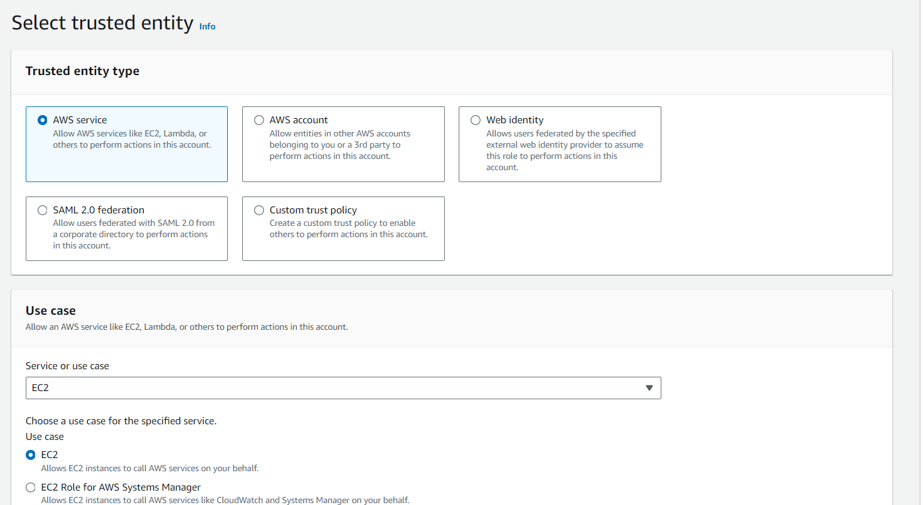

Now, while creating the environment, we are asked to provide an IAM role with the necessary EC2 permissions. We are supposed to make sure that we have made an existing IAM role with the following set of permissions:

1. AWSElasticBeanStalkWebTier
2. AWSElasticBeanStalkWorkerTier
3. AWSElasticBeanStalkMulticontainerDocker

We can skip the steps to follow after the initial few steps mentioned above and move straight to review the settings of our environment. After reviewing everything properly, our environment can successfully be created.

# Step 2: Fork the required repository onto our github account

The repository to be forked is - imoisharma/aws-codepipeline-s3-codedeploy-linux-2.0

This step is necessary for the execution of the steps to follow. It will be helpful in the creation of a pipeline.

# Step 3: Creation of the Pipeline

Navigate to Codepipeline inside Developer Tools. Give a suitable name to the pipeline you want to create.

And click on next …

# Step 4: Github connection

In this step, we are supposed to create a github connection and add our existing repository over here i.e the one we forked earlier

We are supposed to enter our github username so as to proceed towards making the connection

Now to finalize our connection, we are to install an application which connects AWS to our github account and repository.

Post the establishment of the connection, this is the message that is displayed. We can further select the branch of our repository that we want to connect.

# Step 5: Deployment stage:

We are expected to skip the build stage and move towards the deployment step. In the deployment step we are supposed to choose the Elastic Beanstalk application and the environment that we created earlier and proceed with our pipeline creation

